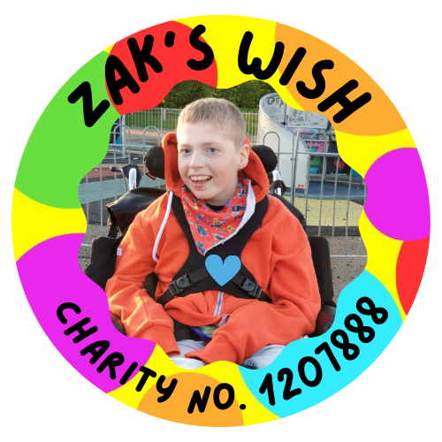

Zak’s Wish

# FUNDING APPLICATION

## Section 1 – Personal Information

|  |  |
| --- | --- |
| 1. Full name of applicant |  |
| 1. Age of applicant |  |
| 1. Gender of applicant |  |
| 1. Address of applicant |  |
| 1. Parents/ Carer / Guardian full name |  |
| 1. Parent/ Carer / Guardian contact number |  |
| 1. Parent / Carer / Guardian email address |  |
| 1. Relationship to applicant |  |

## Section 2 – Medical Information

|  |  |
| --- | --- |
| 1. Does the applicant have a diagnosed medical condition or disability? Please circle YES or NO.   If YES please provide more information: | YES NO |
| 1. Is this condition life limiting? Please circle YES or NO.   If YES please provide more information: | **YES NO** |
| 1. Does the applicant have an educational health care plan? (EHCP). Please circle YES or NO | **YES NO** |
| 1. If the applicant does not have an EHCP are they in the assessment process for an EHCP? (Educational Health care plan)   Please circle YES or NO  (if you circled YES on Q11 please circle NA) | **YES NO NA** |
| 1. If you answered NO on Q11 and Q12 please provide further details on why no EHCP is in place or progress: |  |
| 1. Does the applicant receive DLA or PIP?   (Disability living allowance or personal independence payment).  Please Circle YES or NO | **YES NO** |

## Section 3 – About the applicant

|  |  |
| --- | --- |
| **Briefly describe the interest, hobbies and activities that the applicant enjoys:** |  |
| **How would the funding contribute to enhancing the applicants life and wellbeing?** |  |
| **Are there any specific items or experiences that the applicant has expressed interest in? (e.g. equipment, outings etc.)** Give 3 preferences, (please be advised that although every effort will be made to accommodate your preferences, it may not always be feasible to fulfill all three of your stated desires). |  |

## Section 4 – Additional Information

|  |  |
| --- | --- |
| 1. Are there any other sources of funding or support the applicant is currently receiving? (excluding PIP or DLA) Please circle YES or NO   If yes please specify: | YES NO |
| 1. Is there any additional information you would like to share about the applicants needs or circumstances that may be relevant to the application? |  |

## Declaration and signature

**I certify that the information provided on this application is true and accurate to the best of my knowledge. I understand that any false or misleading information may result in the rejection of this application.**

|  |  |  |  |  |  |  |
| --- | --- | --- | --- | --- | --- | --- |
| Signature: |  |  |  | Date: |  |  |

Thank you for applying to Zak’s Wish. We will review your application and be in touch via the contact details provided in the first section of this form. If you have any questions or need further assistance, please contact us at; [applications@zakswish.co.uk](mailto:applications@zakswish.co.uk) or call us on 07919 284394. (Please note that we can only accept calls between the hours of 9am and 5pm, we do not accept calls on Sundays).